**Adapt Ready Assignment**

Date: 02/08/2024

Name: Punith Kumar P R

Email: [punithkumarpr03@gmail.com](mailto:punithkumarpr03@gmail.com)

USN: 1DS20CS158

College: Dayananda Sagar College of Engineering

**Software development**

1. How we can parse the data from an unstructured data to structured table format using regular expression algorithms in python/Nodejs? with an example which has to be explaining about the workflow ex: Use the OCR reader for parse the raw text (Unstructured data) from an image (some id card) and then make the regular expression algorithm for creating a set of structured data.

* I have used **my college id card** for this demonstration.
* Used **Tesseract OCR** engine for Optical Character Recognition. Used tesseract.js module.

(I also have a project “Lipi” using OCR in node.js. [ [link](https://github.com/punith-kumar-pr/Extraction-and-translation-of-text-from-scripts) ]

* ID card Photo
* A close up of a id card

  Description automatically generated
* Unstructured data or OCR data

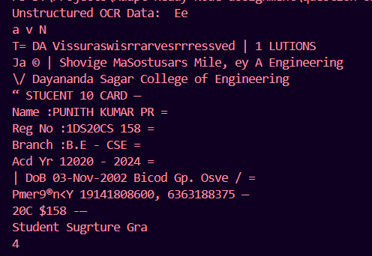

* Now parsed the data Using Regular Expression.

**Note:** I parsed the data based on the output I obtained. Here ‘:’ is recognised as ‘1’. Written regular expression accordingly.

* **Code and explanation:** (missed blood group here, updateded code is available in github [ [link](https://github.com/punith-kumar-pr/adapt_ready_assignment) ])

* Line 9: *ret.data.text* gives the extracted data from image.
* Line 40: getting the structured data by passing the *ret.data.text* to function *parseText()*
* In *parseText* function, there are regular expression pattern for Name, reg no, etc.
* Using string *match()* we use *text.match(regularExpression)*. The *match()* method matches a string against a regular expression. The *match()* method returns an array with the matches.
* Using the returned values, constructed and returned the *structuredData* object.
* **Obtained output:**

1. Dynamic variable declaration and execution in different forms (variables, multi-dimensional arrays) with examples. And how we can perform an operation/action using eval with Nodejs/python.

**Dynamic Variable Decleration and execution.**

* Dynamic variable names don’t have a specific name hard-coded in the script. They are named dynamically with string values from other sources.
* Dynamic variable declaration and execution involve creating variables, arrays, or other data structures at runtime rather than at compile time.
* Can use *eval(), map data structure, using modern JS object property syntax*.

1. **Variables**

Code:

Output:

* **Using Map Data Structure**

Code:

Output:

* **Using eval()**

Code:

Output:

1. **Arrays**

* **1D array**

Code:

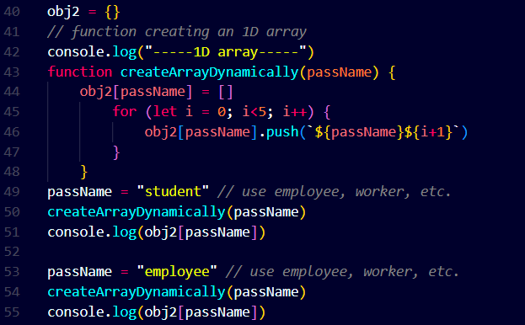

* + Here function *createArrayDynamically()* creates the array with the name passed in the function as a param passName.

Output:

* **Multi-Dimensional array**

Code: Implementation similar to 1D array

Output:

1. **Using *eval():***

The eval() function evaluates JavaScript code represented as a string in the parameter. A string is passed as a parameter to eval(). If the string represents an expression, eval() evaluates the expression. Inside eval(), we pass a string in which variable value i is declared and assigned a value of i for each iteration. The eval() function executes this and creates the variable with the assigned values. The code given below implements the creation of dynamic variable names using eval().

Code:

Output:



* Using *eval()* can be vulnerable. Attackers can exploit it.
  + Modifying the data

Code:

Output:

* + Attackers can make problems to application.

Ex: One can make application throw an error

Code:

* + - Application works fine if *check > 20*.



* + - If *check < 20*



Output:

1. What is the purpose of ssh keys and how we can use the ssh keys in server? explain about authorized keys in ssh with example.

* SSH stands for Secure Shell/ Secure Socket Shell.
* “The Secure Shell Protocol (SSH) is a cryptographic network protocol for operating network services securely over an unsecured network.”
* In general words “SSH keeps publicly transported messages private from public.”
* SSH use public key pairs or asymmetric cryptography to authenticate hosts to each other.

**Purpose of SSH Keys**

* SSH keys are used to access servers securely. They provide a way to authenticate without using passwords, which increases security and convenience.
* SSH keys comes in pairs of **private key** and **public key**.
* Private Key: This key stays on your local machine and should be kept secret. It's used to decrypt messages that were encrypted with the public key.
* Public Key: This key is placed on the server and can be shared openly. It’s used to encrypt messages that only the corresponding private key can decrypt.

**How to generate and use SSH keys.**

1. **Generate SSH key**

* Open git bash in local machine and enter the following command
  + ssh-keygen -t rsa -b 4096 -C "myemail@email.com"

* This will generate a private key (id_rsa) and a public key (id_rsa.pub) in the ~/.ssh directory.
* Check for it using the ‘ls’ command
  + ls ~/.ssh

1. **Copy public key to servers ‘~/.ssh/authorized_keys’**

What are **authorized_keys**?

The authorized_keys file is used to store the public keys that are allowed to connect to the server. Each line in the authorized_keys file contains a single public key. When an SSH client attempts to connect, the server checks if the client’s public key is in the authorized_keys file.

* Following command will copy public key into *authorized_keys.*
  + ssh-copy-id user_name@server_ip_address
* Or append manually with cat command
  + cat ~/.ssh/id_rsa.pub | ssh user@server 'cat >> ~/.ssh/authorized_keys'

* Or copy manually the public key into authorized_keys in server.

1. **Connect to server**
   * connect to server with below command
     + ssh user_name@server_ip_address